THINK VEG BOX • THINK AUSTEN’S PREMIUM
D3 SPECTRUM BUSINESS CENTRE
ANTHONY’S WAY
ROCHESTER ME2 4NP
T: 01634 816100
E: contact@austensgroup.com
W: www.austensgroup.com

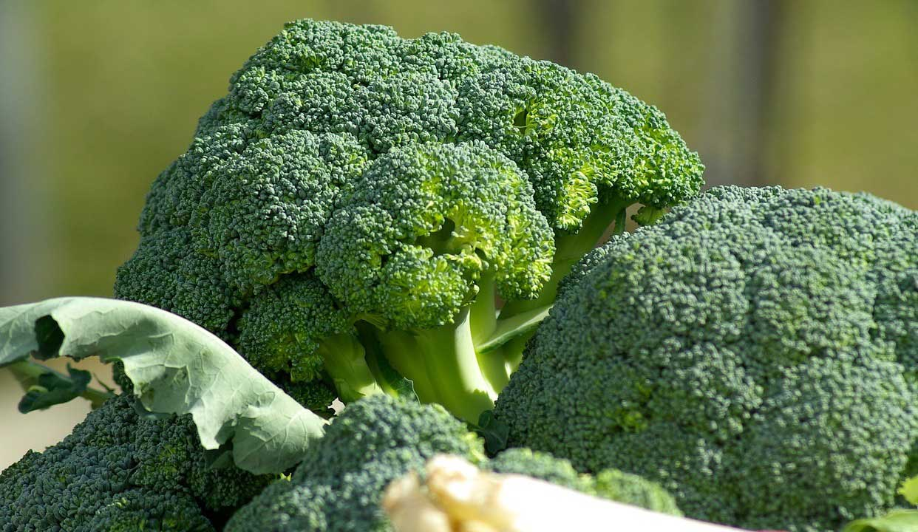
VEG BOX CONTENTS & RECIPES FOR WEEK COMMENCING 27TH MARCH 2023

E A T L O C A L ⋅ L I V E B E T T E R

VEG BOX CONTENTS

BOX SIZE &  CONTENTS | SMALL  BOX | MEDIUM  BOX | LARGE  BOX | WHERE IT IS GROWN | STORAGE INSTRUCTIONS
LOCAL COX APPLES | √ | √ | √ | Coxheath | Room temperature
LOCAL CONFERENCE PEARS | √ | √ | √ | Coxheath | Room temperature
BANANAS | √ | √ | √ | Costa Rica | Room temperature
LOCAL MARIS PIPER POTATOES | √ | √ | √ | Birchington | Cool, dark place
LOCAL SPRING GREENS | √ | √ | √ | Thanet | Refrigerate
LOCAL CAULIFLOWER | √ | √ | √ | Dover | Refrigerate
ENGLISH PARSNIPS | √ | √ | √ | Herts. | Refrigerate
BROCCOLI | √ | √ | √ | Spain | Refrigerate
LOCAL VINE TOMATOES | X | √ | √ | Thanet | Refrigerate
LOCAL OAKLEAF LETTUCE | X | √ | √ | West Malling | Refrigerate
ENGLISH LOOSE CARROTS | X | X | √ | Lancs. | Refrigerate
CUCUMBER | X | X | √ | Spain | Refrigerate

This week’s savoury recipe 1

BRAISED SPRING GREENS WITH PARMESAN & GARLIC

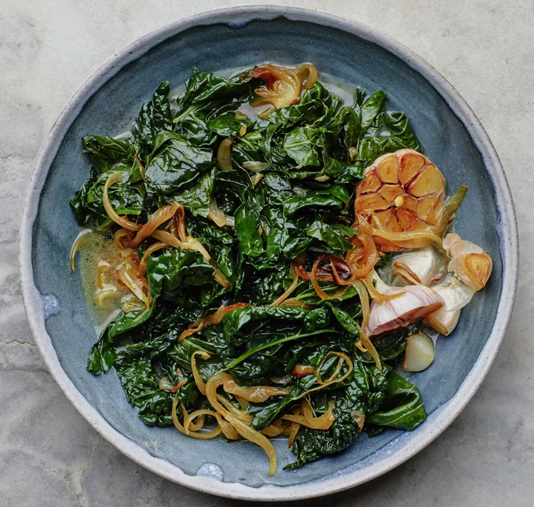
Ingredients, serves 4

⅓ cup extra-virgin olive oil,
plus more for serving
1 head of garlic, halved crosswise
1 large onion, thinly sliced
sea salt
freshly ground pepper
400g spring greens, ribs and
stems removed, leaves torn
2 oz parmesan, finely grated

Method

Heat ⅓ cup of oil in a me over medium. Arrange garlic halves, cut side down, in pot and scatter onion around; season with salt and pepper. Cook, stirring onion occasionally but keeping garlic cut side down, until onion is deep golden, 6–8 minutes.

Add the spring greens to the pan by the handful, stirring and letting it wilt slightly before adding more; season generously with salt. Cook, stirring often, until all of the spring greens are a deep green and just wilted, about 3 minutes. Add 1½ cups water, cover pot partially with a lid, and cook until liquid is reduced by half and the greens are tender, 12–15 minutes.

Add the parmesan to the braised greens and cook, stirring, until cheese is melted and incorporated (the sauce will thicken slightly), about 5 minutes. Taste and season with more salt and pepper if needed.

We recommended squeezing out the tender garlic cloves from the skins and mashing into the broth, or spreading them onto toast with an extra drizzle of olive oil. Discard skins.

This week’s savoury recipe 2

STICKY SESAME CAULIFLOWER

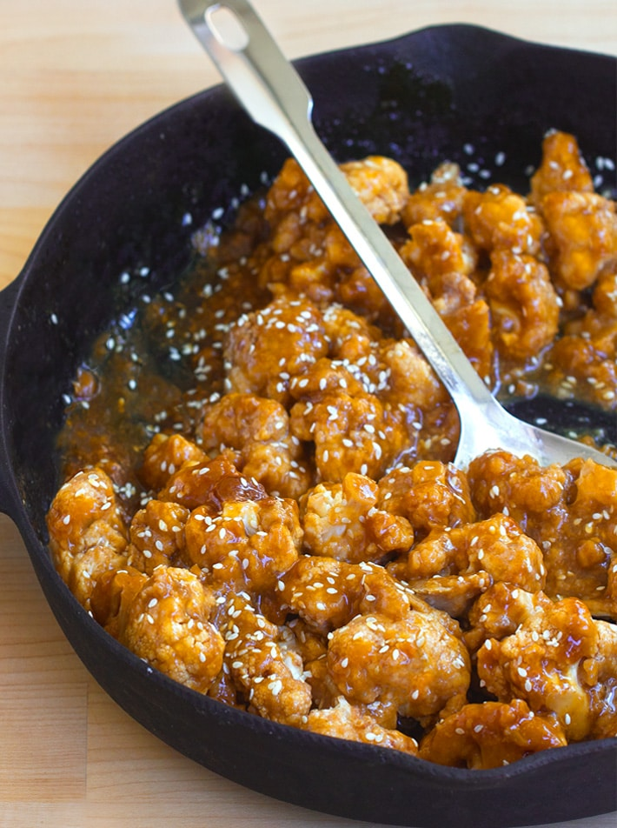
Ingredients – Serves 4

1 cauliflower, chopped
80ml soy sauce
60ml maple syrup or honey
60ml rice vinegar
1 tbsp minced garlic
1½ tsp sesame oil/any
½ tsp ground ginger
1½ tbsp cornflour
¼ cup cold water
Sesame seeds for garnish

Method

Preheat your oven to 450 F. Grease a baking pan or line with
parchment.

Cut cauliflower into florets, then slice so one side of each floret is flat. Arrange in a single layer in the greased pan. Bake for 10 minutes on the centre rack.

Meanwhile, whisk together the soy sauce, maple syrup/honey, vinegar, garlic, oil and ginger in a saucepan. Bring to a boil. While waiting, stir together the cornflour and cold water until it dissolves fully, then slowly whisk this into the saucepan as soon as it boils.

Turn the heat to medium and cook for 2 minutes, stirring more frequently once it returns to a boil. Cook until thick.

Flip the cauliflower florets and bake for 10 additional minutes. Pour your sauce over the florets and sprinkle the sesame seeds on top and serve immediately.

This week’s savoury recipe 3

SIMPLE CHEESY BROCCOLI PASTA BAKE

Ingredients - Serves 4-6
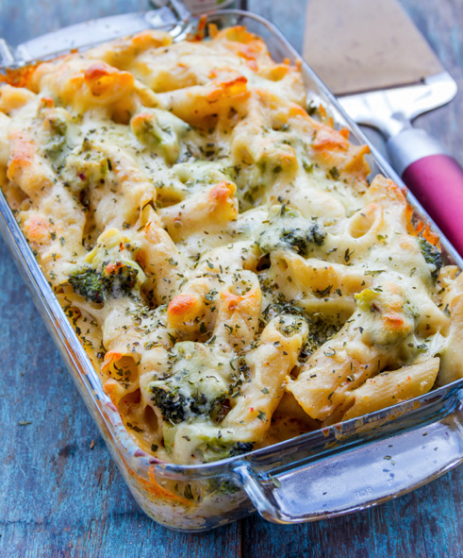
500g dry pasta of your choice
2 cups broccoli florets, – 2 cups,
cut into ½-1 inch pieces
2 tbsp olive oil
2-4 garlic cloves, minced
1 tbsp plain flour
2 cups milk
1 tbsp Dijon mustard
½ tsp paprika
1 tsp Italian seasoning
1 tsp dried parsley
200g cheddar cheese, grated
½ cup parmesan cheese
½ tsp freshly ground black pepper
salt to taste

Method

Preheat your oven to 180 C / 350 F and place the wire rack at the centre of the oven.

Cook the pasta until al dente in salted boiling water according to the package directions. Add the broccoli florets to the boiling water for the last two minutes of cooking the pasta. Drain the pasta and broccoli and set aside.

Meanwhile, heat the olive oil in a large pan over medium heat. When the oil warms up, add the minced garlic and cook for a minute or two until it begins to brown.

Next add the flour and whisk until a smooth roux forms. Add the milk, mustard and the spices and continue whisking until the mixture thickens, about 1-2 minutes.

When the sauce begins to bubble, add the cheddar cheese and stir until melted. Add the pasta and broccoli to the sauce and stir until combined. Pour the pasta mixture into an oven safe casserole dish and sprinkle the freshly grated parmesan on top.

Bake until the pasta is warmed through and the top is golden brown, about 15-20 minutes. Serve warm.
This week’s savoury recipe 4

OAKLEAF & EGG SALAD WITH HORSERADISH VINAIGRETTE

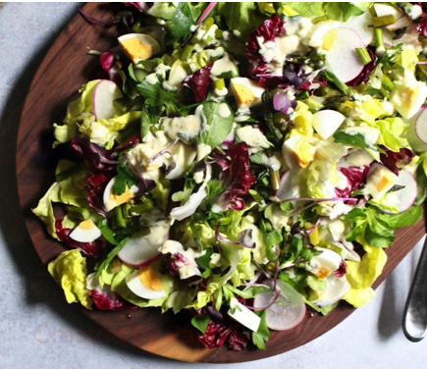
Ingredients – Serves 4

2 free range eggs
4 large handfuls of oakleaf lettuce,
torn into 1½ inch pieces
1 small handful fresh parsley or any herbs,
roughly chopped (optional)
½ cup greek-style yogurt
(optional, but recommended)
1 tablespoons horseradish sauce
1 small clove of garlic, minced
2 teaspoons Dijon mustard
1 tablespoon + ¼ cup olive oil, divided
1 tablespoon white wine vinegar
Sea salt
Freshly ground black pepper

Method

Place eggs in a small pot and cover with 2 inches cold water. Bring to a boil, remove from heat, cover, and let stand for 10 minutes. Transfer eggs to an ice bath, peel, and slice into quarters.

In a separate bowl, combine the yogurt, horseradish sauce, garlic, mustard, vinegar and a pinch of salt and pepper in a small bowl. Add the olive oil in a slow and steady steam, whisking until dressing is emulsified. Taste with a piece of lettuce, and adjust if needed.

Arrange lettuce on a serving platter, scatter with radish, egg and parsley or herbs (if using). Drizzle with the vinaigrette and serve immediately.

This week’s sweet recipe 1

APPLE & RUM CAKE
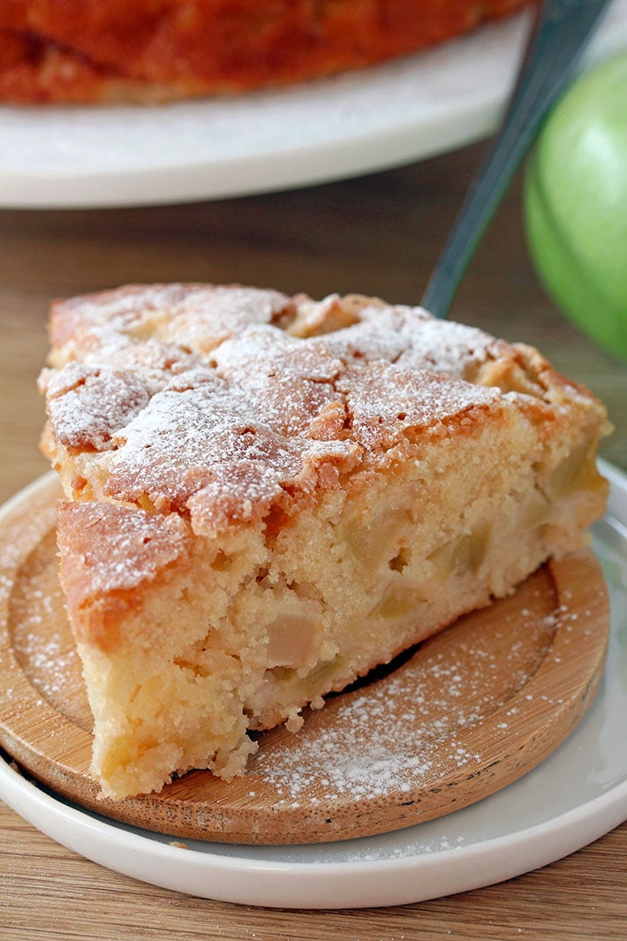

Ingredients, serves 4

4 cox apples
1 cup plain flour
1 teaspoons baking powder
¼ teaspoons salt
8 tablespoons butter, softened
¾ cup + 1½ tablespoons
granulated sugar
2 large eggs
1 teaspoon vanilla extract
¼ cup dark rum
knob butter to grease the pan

Instructions

Preheat the oven to 350 F and prepare a 9 inch spring form or cake pan by lining it with parchment paper and butter and then set it aside.

Peel the apples next and cut them into ½ inch dices, then set aside. In a medium dish, sift flour, baking powder and salt and set aside. In a large dish, beat butter and ¾ cup sugar, using medium-high speed, until it becomes light and fluffy, then add eggs and beat until well combined.

Next, beat in vanilla and rum, change the speed to low and beat in a ¼ of
flour mixture until just incorporated. Continue adding the same amount of the flour mixture until you use it all up, beating all the time. Fold in the apples and pour the batter in the pan that has already been prepared, spreading it evenly. Sprinkle 1½ tablespoon granulated sugar and bake for 40 minutes or until the top becomes golden brown or the toothpick comes out clean or with a few crumbs on it.

When the cake is done, take it out of the oven and leave in the pan for a few minutes to cool, then transfer, carefully on the cake plate and sprinkle with powdered sugar. Serve with vanilla or cinnamon ice cream, or with whipped cream.

This week’s sweet recipe 2

NO BAKE BANOFFEE PIE

Ingredients, serves 8

250g digestive biscuits, crushed
100g butter, melted
1 tin Carnation Caramel (397g)
2 Bananas
1 300ml carton whipping cream,
whipped to soft peaks
Grated chocolate to sprinkle

Method

Put the crushed biscuits into a bowl with the melted butter. Mix it together thoroughly, then press the mixture into the base and sides of the tin. Chill for 30 minutes in the fridge.
Simply spoon the caramel from the tin into the base and spread gently to the edges. There’s no need to beat the caramel first.
Remove the pie base from the tin. Slice the bananas and scatter them over the caramel. Top with the softly whipped cream. For the perfect finishing touch, dust with cocoa powder or use grated chocolate to decorate the banoffee pie. Chill until ready to serve.

For super speedy setting, put the base in the freezer for 10 minutes instead of the fridge.

