D3 Spectrum Business Centre
Anthony’s Way
Rochester ME2 4NP
T: 01634 838775
E: contact@austensgroup.com
W: www.austensgroup.com

VEG BOX CONTENTS & RECIPES FOR WEEK COMMENCING 19th OCTOBER 2020

E A T L O C A L ⋅ L I V E B E T T E R

VEG BOX CONTENTS

BOX SIZE &  CONTENTS | SMALL  BOX | MEDIUM  BOX | LARGE  BOX | WHERE IT IS GROWN | STORAGE INSTRUCTIONS
LOCAL PUMPKIN | √ | √ | √ | Hoo | Room temperature
LOCAL BRAEBURN APPLES | √ | √ | √ | Coxheath | Room temperature
SATSUMAS | √ | √ | √ | Spain | Room temperature
LOCAL BABY POTATOES | √ | √ | √ | Birchington | Cool, dark place
LOCAL BUNCHED BEETROOT | √ | √ | √ | Halling | Refrigerate
LOCAL LEEKS | √ | √ | √ | Boughton | Refrigerate
LOCAL CARROTS | √ | √ | √ | Canterbury | Refrigerate
LOCAL WHITE ONIONS | √ | √ | √ | Deal | Cool, dark place
LOCAL KALE | X | √ | √ | Boughton | Refrigerate
CHESTNUT MUSHROOMS | X | √ | √ | France | Refrigerate in a  paper bag
LOCAL SWEDE | X | X | √ | Thanet | Refrigerate
LOCAL VINE TOMATOES | X | X | √ | Thanet | Refrigerate, eat raw at room temparature

This week’s savoury recipe

SAUSAGE & LEEK BAKE

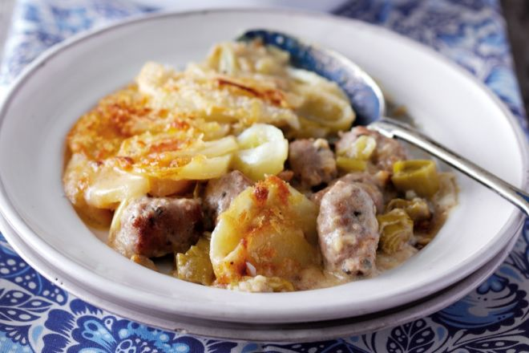
Ingredients – serves 6

700g potatoes, peeled and sliced
25g butter
450g sausages, cut into thick slices
1 onion, peeled and sliced
4 leeks, cleaned and sliced
40g plain flour
450ml milk
110g smoked Cheddar
25g breadcrumbs

Instructions

Preheat the oven to 200°C/180°fan/Gas 6.
Cook the potatoes in boiling salted water for 4-5 minutes until just tender. Drain.
Meanwhile, melt the butter in a large pan, add the sausage slices and cook for 5 minutes. Add the onion and leeks and cook for a further 5 minutes. Add the flour, cook for 1 minute, then gradually add the milk and 75g of the cheese, stirring. Bring to the boil and simmer for 1–2 minutes, stirring continuously.
Transfer to a 2-litre ovenproof dish, arrange the potato slices on top, sprinkle with the breadcrumbs and the remaining cheese and bake for 20 minutes until browned.
Serve hot.

This week’s sweet recipe
OLD FASHIONED PUMPKIN PIE

Ingredients – Serves 4
2 eggs plus the yolk of a third egg
½ cup packed dark brown sugar
½ cup caster sugar
½ teaspoon low salt
2 teaspoons of cinnamon
1 teaspoon ground ginger
¼ teaspoon ground nutmeg
¼ teaspoon ground cloves
¼ teaspoon ground cardamon
½ teaspoon of lemon zest
2 cups of pumpkin pulp purée
1 12oz. can of evaporated milk
Ground black pepper

Instructions

To make your pumpkin purée, cut pumpkin in half and scrape out the insides (reserving the pumpkins seeds to toast) and discard. Line a baking sheet with foil and place the pumpkin halves cut side down on the lined baking sheet and bake at 350°F/190°C until a fork can easily pierce them, about an hour to an hour and a half. Remove from the oven, allow to cool and scoop out the pulp.

To make your pie, preheat your oven to 425°F/220°C. Beat the eggs in a large bowl. Mix in the brown sugar, white sugar, salt, spices—cinnamon, ground ginger, nutmeg, ground cloves, cardamom, lemon zest and ground black pepper (don’t be put off, it really works. Mix in the pumpkin purée. Stir in the cream. Beat together until everything is well mixed.

Pour the filling into an uncooked pie case, shop bought if you don’t have time to make your own. Bake at a high temperature of 425°F/220°C for 15 minutes. Then after 15 minutes, lower the temperature to 350°F/180°C. Bake for 45 to 55 minutes more, or until a knife inserted in the centre comes out clean. (About half-way through the baking, you may want to put foil around the edges to keep the crust from getting too browned).

Cool the pumpkin pie on a wire rack for 2 hours. Note that the pumpkin pie will come out of the oven all puffed up (from the leavening of the eggs), and will deflate as it cools. Best served with whipped or ice-cream.

