D3 Spectrum Business Centre
Anthony’s Way
Rochester ME2 4NP
T: 01634 838775
E: contact@austensgroup.com
W: www.austensgroup.com

VEG BOX CONTENTS & RECIPES FOR WEEK COMMENCING 30TH NOVEMBER 2020
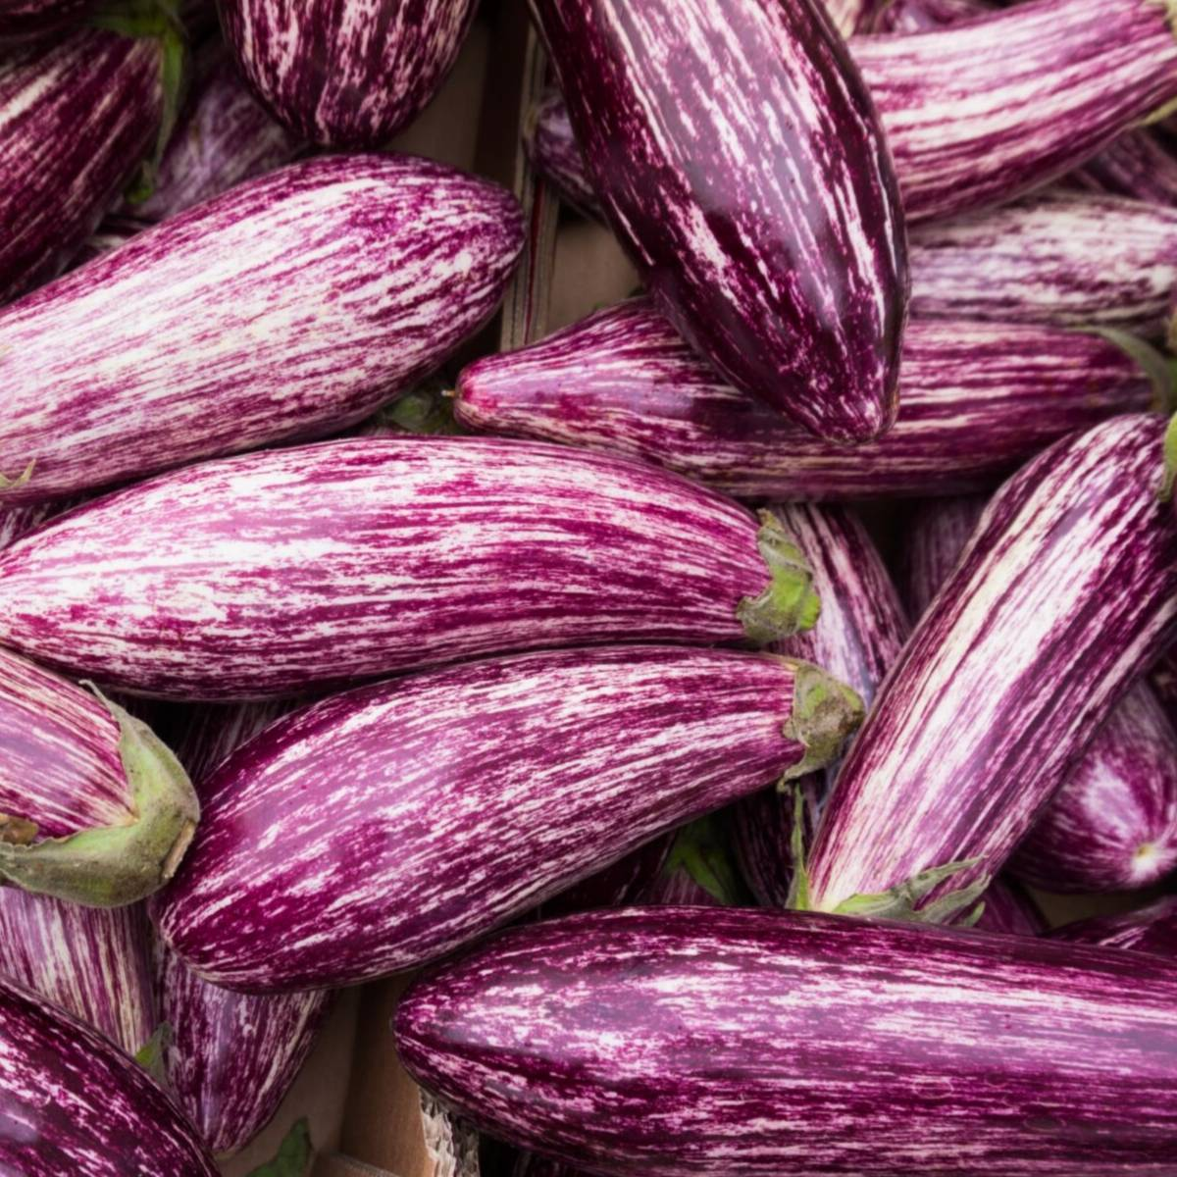

E A T L O C A L ⋅ L I V E B E T T E R

VEG BOX CONTENTS

BOX SIZE &  CONTENTS | SMALL  BOX | MEDIUM  BOX | LARGE  BOX | WHERE IT IS GROWN | STORAGE INSTRUCTIONS
LOCAL COX APPLES | √ | √ | √ | Coxheath | Room temperature
NAVAL ORANGES | √ | √ | √ | Spain | Room temperature
BLUEBERRIES | √ | √ | √ | Various | Room temperature
LOCAL BAKING POTATOES | √ | √ | √ | Birchington | Cool, dark place
LOCAL HISPI POINTY CABBAGE | √ | √ | √ | Thanet | Refrigerate
STRIPEY AUBERGINES | √ | √ | √ | Spain | Refrigerate
PURPLE & WHITE CARROTS | √ | √ | √ | Various | Refrigerate
BABY SPINACH | √ | √ | √ | Spain | Refrigerate
LOCAL CHERRY  VINE TOMATOES | X | √ | √ | Thanet | Cool, dark place
RED ROMERO PEPPERS | X | √ | √ | Spain | Cool, dark place
LOCAL SUPERFOOD BABYLEAVES | X | X | √ | West Malling | Refrigerate
LOCAL ONIONS | X | X | √ | Dover | Refrigerate

This week’s savoury recipe

MID-WEEK AUBERGINE & SPINACH PENNE PASTA

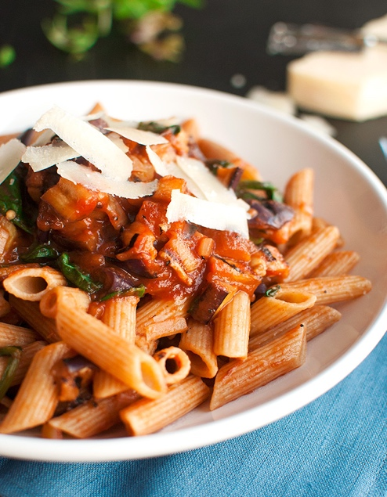
Ingredients – serves 2

1 medium-sized stripey aubergine, washed
200g dry penne pasta
1 medium-sized onion
1 tablespoon rapeseed or olive oil
1 clove of garlic
400g passata or tomato purée
2 large handfuls spinach,
washed and roughly chopped
1 teaspoon balsamic vinegar
salt and black pepper
parmesan, to serve

Method

Bring a pot of water to a boil to cook the pasta. Heat a griddle pan over high heat.

Slice the eggplant lengthwise into 1-cm (or about ½-inch) thick slices and place the slices on the hot griddle pan. Crank the heat down to medium-high and cook the eggplant slices in batches, turning them once they have a nice charred griddle pattern, about 1-2 minutes per side. Once both sides are charred, transfer to a plate and set aside.

Add the dried pasta to the boiling water, salt the water, and cook according to the manufacturer’s instructions (usually about 11 minutes). Make sure to stir every now and then.
In the meantime, heat a medium-sized saucepan over medium heat. Peel and chop the onion, add the oil to the hot pan, add the onion and cook for about 2 minutes over low heat, or until translucent. Add the spinach and cook for a few minutes until welted, stirring regularly.

Mince the garlic and add it to the spinach and onion pan. Cook for 1 minute, stirring constantly. Chop the eggplant into bite-sized cubes, then add it to the pan, along with the passata and balsamic vinegar. Crank the heat up to high and stir until the sauce comes to a boil. Don’t forget to stir the pasta every now and then. Add salt and pepper to taste.

When the pasta is cooked, drain it. Add the sauce to the pasta, divide over two plates and top with fresh Parmesan shavings. Serve immediately.
This week’s sweet recipe
APPLE & BLUEBERRY FLAPJACKS

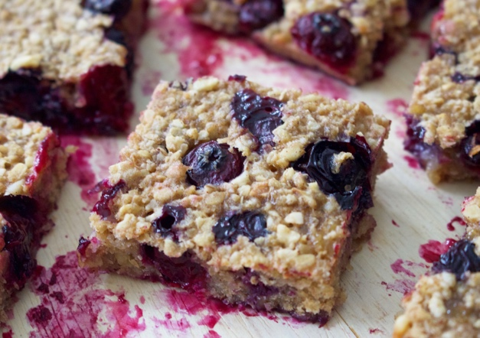
Ingredients – Makes 12

200g (7oz) butter
200g (7oz) caster sugar
150g (5oz) runny honey
425g (15oz) porridge oats
2 cox apples, peeled, cored, grated
¾tsp ground cinnamon
Punnet blueberries, washed
and lightly mashed
75g (3oz) sunflower seeds
75g (3oz) Brazil nuts, chopped

Instructions
- Heat the oven to 180C, 160C fan, 350F, gas 4. Prepare an 8x12in tin, the base lined with baking parchment.

- Melt the butter, sugar and honey in a medium saucepan until dissolved, and mix until well combined. Remove from the heat and stir in the remained ingredients, mixing well and coating evenly.

- Spoon into the prepared tin then spread and flatten to create a smooth top. Bake for 45 minutes. Set aside to cool completely before turning out. Cut into bars. These will keep in an airtight container for several days.

