THINK VEG BOX • THINK AUSTEN’S PREMIUM
D3 SPECTRUM BUSINESS CENTRE
ANTHONY’S WAY
ROCHESTER ME2 4NP
T: 01634 816100
E: contact@austensgroup.com
W: www.austensgroup.com

VEG BOX CONTENTS & RECIPES FOR WEEK COMMENCING 5TH DECEMBER 2022

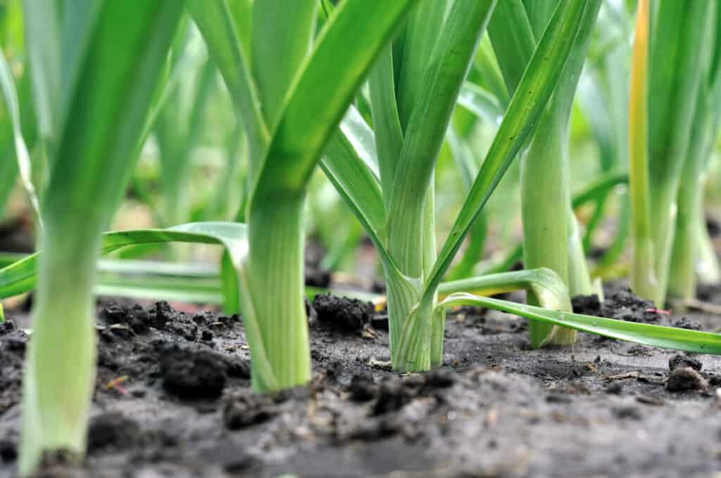

E A T L O C A L ⋅ L I V E B E T T E R

VEG BOX CONTENTS

BOX SIZE &  CONTENTS | SMALL  BOX | MEDIUM  BOX | LARGE  BOX | WHERE IT IS GROWN | STORAGE INSTRUCTIONS
LOCAL COX APPLES | √ | √ | √ | Coxheath | Room temperature
NAVEL ORANGES | √ | √ | √ | Spain | Room temperature
BANANAS | √ | √ | √ | Costa Rica | Room temperature
LOCAL KING EDWARD POTATOES | √ | √ | √ | Birchington | Cool, dark place
ENGLISH LOOSE CARROTS | √ | √ | √ | Herts. | Refrigerate
LOCAL SAVOY CABBAGE | √ | √ | √ | Dover | Refrigerate
LOCAL LEEKS | √ | √ | √ | Thanet | Refrigerate
COURGETTES | √ | √ | √ | Spain | Refrigerate
LOCAL CAULIFLOWER | X | √ | √ | Thanet | Refrigerate
LOCAL SWEDE | X | √ | √ | Deal | Cool, dark place
LOCAL VINE TOMATOES | X | X | √ | Thanet | Refrigerate
RED BELL PEPPERS | X | X | √ | Spain | Refrigerate

This week’s savoury recipe 1

SAVOY CABBAGE & SAGE LASAGNE

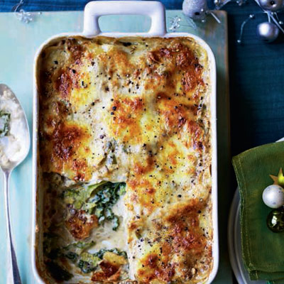
Ingredients – Serves 6

750ml whole milk
1 bay leaf
1 small onion
3 garlic cloves, bruised
6 lasagne sheets
½ savoy cabbage, cored and cut into 2 cm strips
45g unsalted butter, plus extra for greasing
3 tbsp plain flour
6 fresh or dried chopped sage leaves
1 pinch freshly grated nutmeg
125g torn mozzarella
20g grated parmesan

Instructions

Bring the milk to the boil with the bay leaf, onion and garlic. Set aside for 15 minutes to infuse, then strain.
Meanwhile, cook the lasagne sheets in boiling water for 3 minutes until al dente, then refresh in cold water. Drain and pat dry on a clean tea towel. Blanch the cabbage in boiling water for 3 minutes; drain. Pat dry thoroughly.
For the sauce, melt the butter over a low heat and add the flour and sage. Stir for 2 minutes, then slowly pour in the infused milk, whisking all the time until smooth. Simmer for 3-4 minutes. Add the nutmeg and season.
Preheat the oven to 200°C, gas mark 6. Grease a 22cm x 16cm baking dish. Set aside one third of the sauce and stir the cabbage into the rest. Cover the base of the dish with a little of the plain sauce, then top with 2 lasagne sheets. Cover with half the cabbage, then add another 2 lasagne sheets and the remaining cabbage. Top with the final 2 lasagne sheets, spoon over the remaining plain sauce and scatter with the cheeses. Bake for 40-45 minutes until golden.

This week’s savoury recipe 2

COURGETTE & CARROT FRITTERS

Ingredients, makes 8

1 courgette
2 carrots
½ cup plain flour
½ tsp baking powder
¼ teaspoon garlic powder
¼ teaspoon onion powder
1/8 teaspoon salt
1/8 teaspoon pepper
1 egg
2 tbsp oil

Method

Using a grater (ideally box), shred the courgettes and carrots. In paper towels or a tea towel, ring out the courgettes and carrots to release excess moisture.
In a large bowl, combine the flour, baking powder, garlic powder, onion powder, salt, and pepper with the courgettes and carrots. Toss to coat.
In a small bowl, whisk egg, then add to the courgette and carrot mixture. Stir to combine.
In a large pan, add the oil and heat over a high-medium heat. Drop about a ¼ cup scoop of the mixture into the pan. Slightly flatten to create a 2-inch patty. Cook until lightly brown and then flip and cook until both sides are evenly browned.

This week’s savoury recipe 3

MIDWEEK SAUSAGE & LEEK BAKE

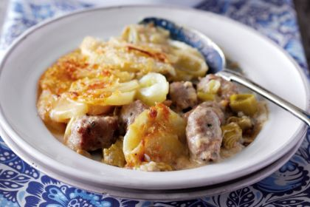
Ingredients, serves 4

700g potatoes, peeled and sliced
25g butter
450g herby sausages,
cut into thick slices
1 onion, peeled and sliced
4 leeks, cleaned and sliced
40g plain flour
450ml milk
110g smoked Cheddar
25g breadcrumbs

Method
Preheat the oven to 200°C/180°fan/Gas 6.
Cook the potatoes in boiling salted water for 4-5 minutes until just tender. Then drain.
Meanwhile, melt the butter in a large pan, add the sausage slices and cook for 5 minutes. Add the onion and leeks and cook for a further 5 minutes. Add the flour, cook for 1 minute, then gradually add the milk and 75g of the cheese, stirring. Bring to the boil and simmer for 1–2 minutes, stirring continuously.
Transfer to a 2-litre ovenproof dish, arrange the potato slices on top, sprinkle with the breadcrumbs and the remaining cheese and bake for 20 minutes until browned. Serve hot with roasted vegetables.

This week’s savoury recipe 4

CHEDDARY CAULFLOWER GRATIN

Ingredients, serves 4-6
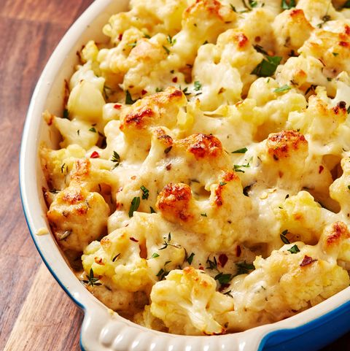

1 cauliflower
2 tbsp butter
2 cloves garlic, minced
2 tbsp plain flour
1½ cups milk
2 cups grated cheddar
½ cup parmesan
salt
ground black pepper
Freshly chopped parsley (optional)

Method
Preheat oven to 375°/180C fan and butter a medium casserole dish. In a large pot of boiling salted water, cook the cauliflower for 3 minutes. Use a slotted spoon to transfer to a bowl of ice water to cool. Drain, then lay cauliflower out on a baking sheet lined with paper towels to let dry completely.
In a large pan over medium heat, melt the butter. Add the garlic and cook until fragrant, about 1 minute. Whisk in the flour and cook until flour is golden and starts to bubble, about 1 minute more. Add milk slowly and stir until mixture comes to a simmer. Boil until slightly thickened, about 1 minute.
Turn off the heat and add 1 cup cheddar and parmesan. Stir until the cheese has melted, then season with salt and pepper.
Add about half the cauliflower to a prepared pan, then pour in half of the creamy mixture. Repeat with the remaining cauliflower and creamy mixture, then top with the 1 cup of cheddar.
Bake until bubbling and golden on top, about 25 minutes.
Garnish with parsley (optional) and serve.
This week’s sweet recipe 1

ORANGE BREAD & BUTTER PUDDING

Ingredients – Serves 4

2 rounded tbsp marmalade
6 slices of bread with crusts left on
2oz softened butter
10fl oz milk
3 large eggs
3oz caster sugar
grated zest of 1 large orange
1 level tbsp demerara sugar

Instructions

Generously butter the slices of bread on one side, then spread the marmalade on three of these slices and put the other three slices on top (buttered side down) so you have got three rounds of sandwiches.

Now spread some butter over the top slice of each sandwich and cut into quarters to make little triangles or squares. Then arrange the sandwiches, butter side up, overlapping each other in a baking dish and standing almost upright.
Whisk the milk, cream, eggs and sugar together and pour this all over the bread.
Scatter the surface of the bread with the grated orange zest and demerara sugar, then place the pudding on a high shelf and bake it for 35-40 minutes at 180℃ until it is puffy and golden and the top crust is crunchy.
Serve straight from the oven while it is still puffy with cream, crème fraiche or custard.

This week’s sweet recipe 2

COX & CINNAMON CRUNCH

Ingredients, serves 6
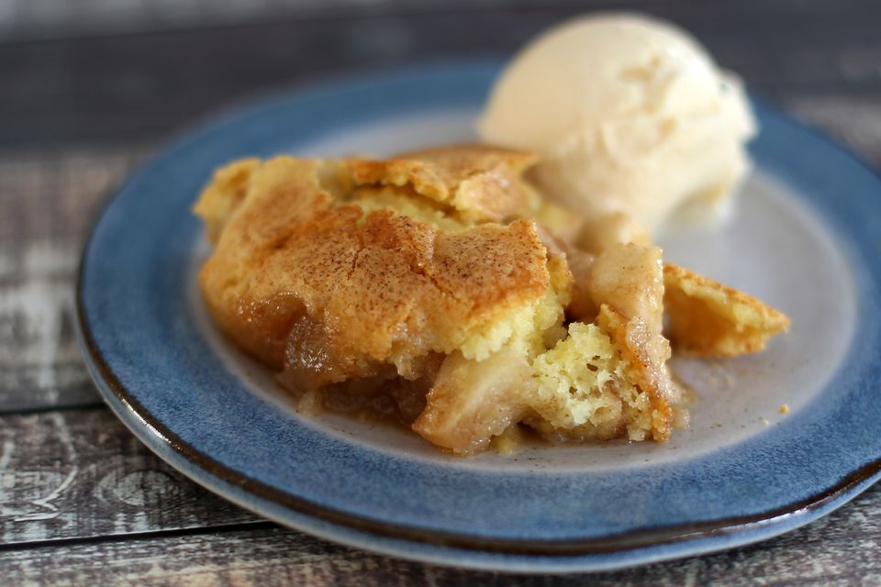
4 cox apples, peeled,
cored & chopped
1 cup sugar
1 teaspoon cinnamon
1 tablespoon butter (cut in small pieces)
For the topping:
1 large egg
½ cup all-purpose flour
½ cup sugar
1 teaspoon baking powder
2 tablespoons butter (melted)

Method

Heat the oven to 350 F/180 C/Gas 4. Butter a medium sized baking dish.
Peel and core the apples. Chop them into ½ inch dice.
In a bowl mix the chopped apples with 1 cup of sugar and the cinnamon: transfer to the prepared baking dish. Dot with the small pieces of butter.
In a medium mixing bowl, whisk the egg. In another bowl combine the flour, ½ cup of sugar and baking powder, blend thoroughly. Add the flour mixture to the beaten egg along with the melted butter. Stir until well blended.
Using a teaspoon, spoon the topping batter evenly over the apple filling.
Bake the apple crunch in the preheated oven for 30 to 35 minutes, or until the apples are tender and the topping is browned.

