D3 SPECTRUM BUSINESS CENTRE
ANTHONY’S WAY
ROCHESTER ME2 4NP
T: 01634 816100
E: contact@austensgroup.com
W: www.austensgroup.com

VEG BOX CONTENTS & RECIPES FOR WEEK COMMENCING 26TH JULY 2021

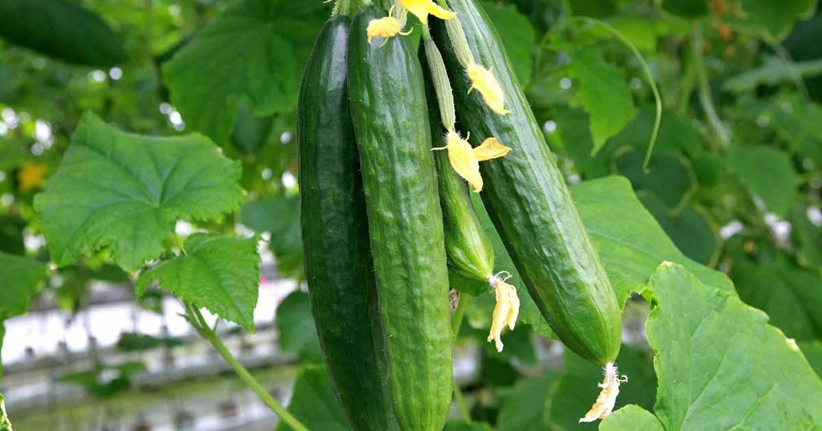

E A T L O C A L ⋅ L I V E B E T T E R

VEG BOX CONTENTS

BOX SIZE &  CONTENTS | SMALL  BOX | MEDIUM  BOX | LARGE  BOX | WHERE IT IS GROWN | STORAGE INSTRUCTIONS
LOCAL STRAWBERRIES | √ | √ | √ | Goodnestone | Refrigerate
ENGLISH BLUEBERRIES | √ | √ | √ | Aylesbeare | Refrigerate
BANANAS | √ | √ | √ | Costa Rica | Room temperature
LOCAL BABY POTATOES | √ | √ | √ | Birchington | Cool, dark place
LOCAL TOMATOES | √ | √ | √ | Halling | Refrigerate
LOCAL BABY SPINACH | √ | √ | √ | West Malling | Refrigerate
LOCAL SUMMER CABBAGE | √ | √ | √ | Boughton Monchelsea | Refrigerate
ENGLISH CARROTS | √ | √ | √ | Lincs. | Refrigerate
LOCAL NAKED CUCUMBERS | X | √ | √ | Halling | Refrigerate
ENGLISH BROCCOLI | X | √ | √ | Lancs. | Refrigerate
LOCAL BELL PEPPERS | X | X | √ | Halling | Refrigerate
RED ONIONS | X | X | √ | Various | Cool, dark place

This week’s savoury recipe

WEEKDAY VEGETARIAN PASTA BAKE WITH SPINACH & TOMATOES

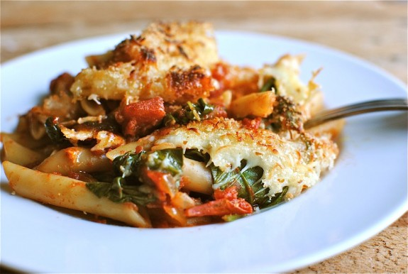
Ingredients – Serves 4

½ onion, diced
3 garlic cloves, minced
1 tbsp. extra-virgin olive oil
1 tbsp. butter
1 pepper
1 tbsp. smoked paprika
300g halved tomatoes
1 tin chopped tomatoes
500g pasta (any), cooked
4 cups baby spinach
2 cups shredded mozzarella
¼ cup breadcrumbs
pinch of salt and pepper

Method

In a medium skillet, heat the oil and butter over medium-high. Once the butter starts bubbling, add the onions. Saute until they start to soften, approx. 5 minutes. Add the garlic, pepper and paprika. Saute for another minute. Stir in all the tomatoes, season with salt and pepper, and simmer 5 to 10 minutes.

Add in the cooked pasta and spinach. Stir to combine. Taste and adjust seasonings if needed.

Pour the mixture into a baking dish, sprinkle with the cheese and breadcrumbs. Bake for 20 minutes. If the cheese isn’t melted and started to bubble and brown, place under the grill for maybe a minute.

This week’s sweet recipe

BEST EVER BLUEBERRY MUFFINS

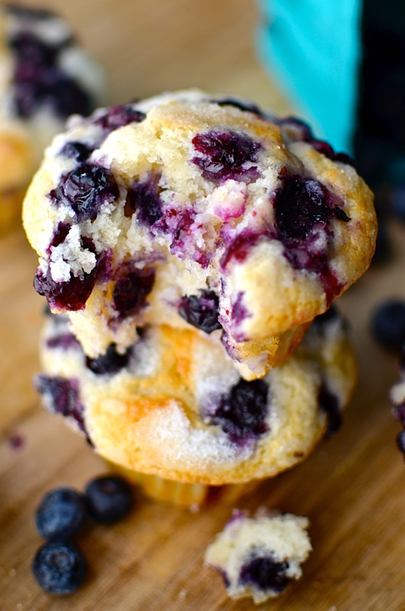

INGREDIENTS – MAKES 8

2/3 cup caster sugar
1 large egg
½ cup vegetable oil
1/3 cup milk
½ teaspoon vanilla extract
1¼ cup all-purpose flour
1 teaspoon baking powder
¼ teaspoon salt
½ cup natural yoghurt/sour cream
125g blueberries
Sprinkle of caster sugar

Instructions
Preheat oven to 375ºF. You may want to lightly grease your muffin tin so that the crown of the muffin doesn't stick to the pan. Place eight muffin liners in the pan. Combine the sugar, egg, oil, milk, and vanilla in a bowl and stir until well combined.
Add the flour, baking powder and salt. Stir the baking powder and salt into the flour right on top of the wet ingredients so you don't have to get out another bowl. Once the baking powder and salt are pretty well distributed in the flour, stir them into the wet ingredients until combined. Don't over-mix. Just stir until it's no longer lumpy.
Stir in the yoghurt/sour cream just until well distributed. Fold in the blueberries leaving some for the top so visible when cooked. Evenly distribute the batter in the muffin tin. If you are making 8 high crowned muffins, you will be filling them all the way to the top. If you want to make shorter muffins you could probably fill 12. If you saved some berries for the top, sprinkle them on and press them in lightly. Sprinkle the tops with the 1 caster sugar if you like.
Bake muffins for about 25 minutes. Just make sure you get them out as soon as a toothpick comes out clean.
You can also make maybe 3 or 4 giant muffins in a jumbo muffin tin. If you do, bake them at 350ºF for maybe about 40 minutes.
Place in a sealed container while they're still warm so the stay really moist.

