137B HIGH STREET
ROCHESTER ME1 1EW
T: 01634 838775
E: contact@austensgroup.com
W: www.austensgroup.com

VEG BOX CONTENTS & RECIPES FOR WEEK COMMENCING 17th FEBRUARY 2020

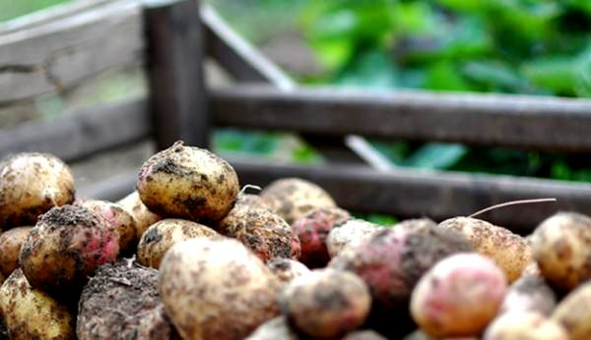

E A T L O C A L ⋅ L I V E B E T T E R

VEG BOX CONTENTS

BOX SIZE &  CONTENTS | SMALL  BOX | MEDIUM  BOX | LARGE  BOX | WHERE IT IS GROWN | STORAGE INSTRUCTIONS
LOCAL COX APPLES | √ | √ | √ | Loose | Room temperature
BLOOD ORANGES | √ | √ | √ | Spain | Room temperature
BANANAS | √ | √ | √ | Costa Rica | Room temperature
LOCAL KING EDWARD POTATOES | √ | √ | √ | Birchington | Cool, dark place
LOCAL BUNCHED CARROTS | √ | √ | √ | Thanet | Refrigerate
LOCAL LEEKS | √ | √ | √ | Dartford | Refrigerate
LOCAL VINE TOMATOES | √ | √ | √ | Thanet | Refrigerate, eat at room temperature
COURGETTES | √ | √ | √ | Spain | Refrigerate
LOCAL CELERIAC | X | √ | √ | Canterbury | Refrigerate
LOCAL WHITE ONIONS | X | √ | √ | Dover | Cool, dark place
AUBERGINES | X | X | √ | Spain | Refrigerate
CUCUMBER | X | X | √ | Spain | Refrigerate

This week’s savoury recipe

QUICK & EASY POTATO, LEEK & BACON BAKE

Ingredients, serves 4

400g bacon
1kg potatoes
300g leeks
300g carrots
1 tin chicken soup
75g cheddar cheese or similar, grated
Salt & black pepper
15ml oil
1 ovenproof dish

Method

Preheat the oven to 180°C (160°C fan).

Chop the bacon into chunks and sauté in a frying pan with the oil for 5-6 minutes until just coloured. Peel the potatoes and cut into medium sized slices (not too thick) Chop the leeks into slices, wash well and drain (use only the white and lightly green part of the leeks).

Put the potato and leek slices into a pan of cold slightly salted water, bring to the boil, cover and cook for 5 minutes then drain well.

Place the potato, leek slices and the bacon into the baking dish, pour over the soup and gently mix and season with some black pepper. Sprinkle over the grated cheese and bake in the oven for 20 - 25 minutes until golden.

Meanwhile peel the carrots and cut into thick matchsticks. Cook in some boiling salted water for 6 - 8 minutes.

Drain and serve alongside the potato bake.

This week’s sweet recipe

BLOOD ORANGE GALETTES

Ingredients, serves 6

1 sheet puff pastry
3 medium blood oranges
3 tbsp brown sugar
2 tbsp flour
2 tbsp unsalted butter

Method

Preheat oven to 350F. Line a baking tray with parchment paper.
Lay out the square of puff pastry onto a lightly floured board. Go over the pastry with a rolling pin to smooth it out and make it a little bigger, about 1 inch more on each side. Cut the puff pastry into three strips and then cut each strip in half.
Cut the ends off of three blood oranges and then slice down to cut off the rind. Slice each orange into 6 wagon wheel slices. Try to remove as much of the centre pith as possible without destroying the slices.
Arrange the puff pastry pieces onto the baking tray. Sprinkle each one with brown sugar, using 1½ tablespoons in total. Then add 1 teaspoon of flour in a stripe down the middle of the piece. Top with 3 orange slices, layered so they overlap each other. Then sprinkle on the rest of the brown sugar and dot with butter.
Bake the orange galettes for 28-30 minutes. Transfer them to a cooling rack. Serve warm or at room temperature topped with custard or ice cream.

