D3 SPECTRUM BUSINESS CENTRE
ANTHONY’S WAY
ROCHESTER ME2 4NP
T: 01634 816100
E: contact@austensgroup.com
W: www.austensgroup.com

VEG BOX CONTENTS & RECIPES FOR WEEK COMMENCING 21ST JUNE 2021
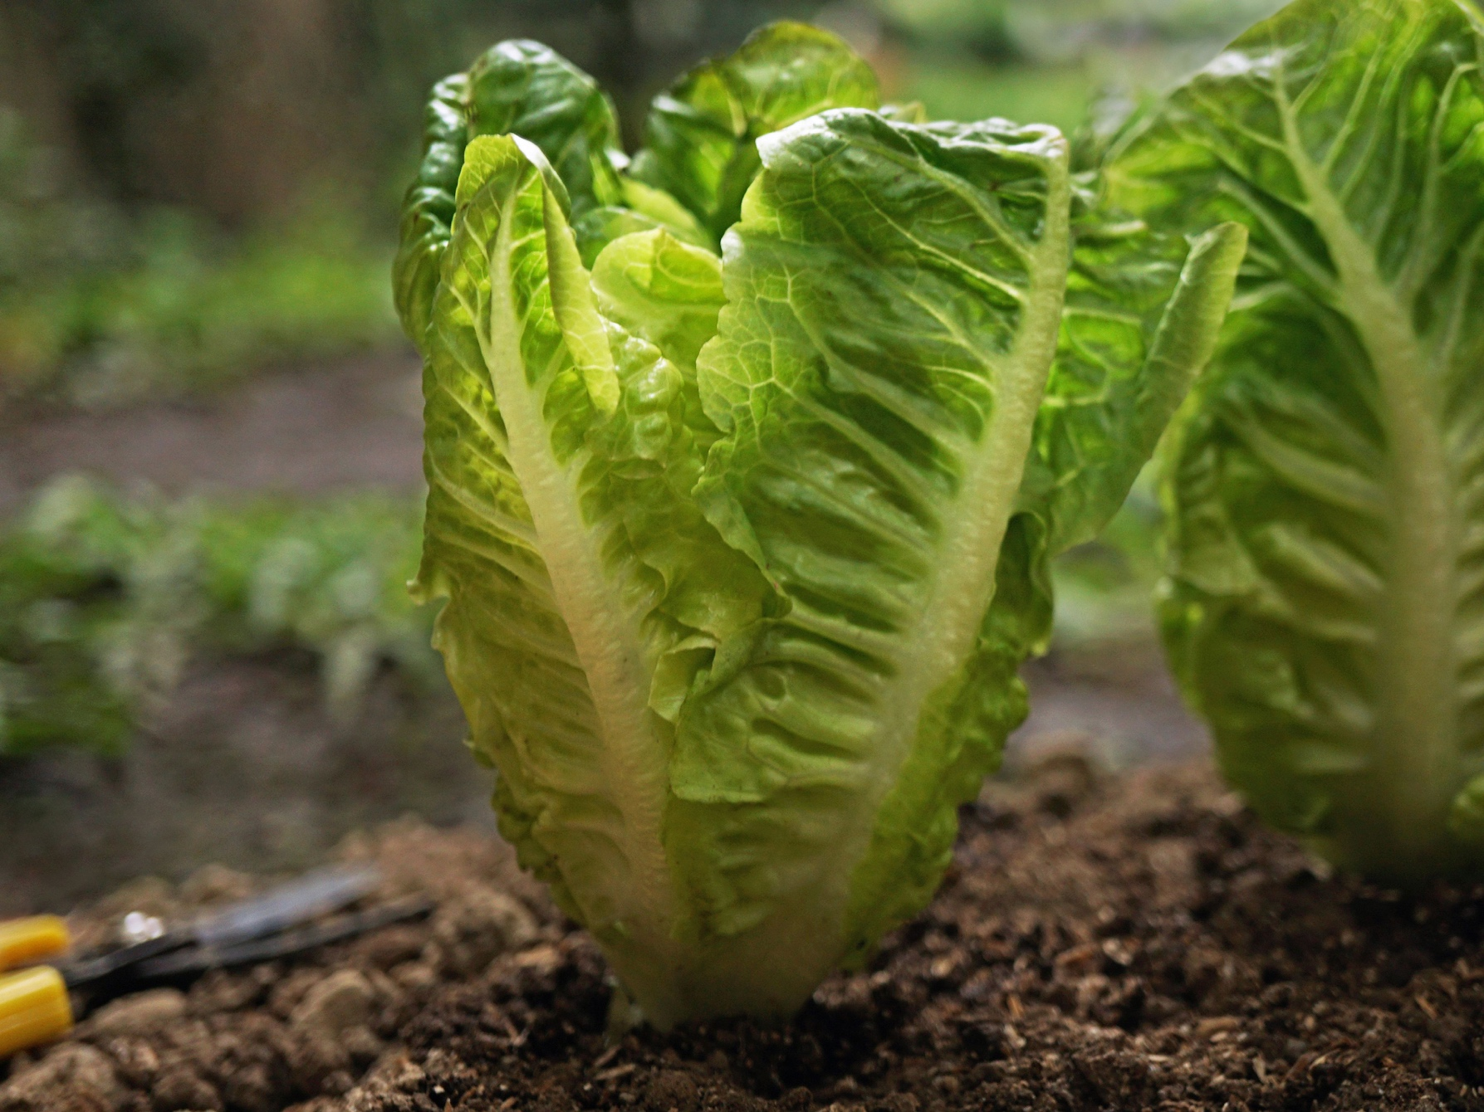

E A T L O C A L ⋅ L I V E B E T T E R

VEG BOX CONTENTS

BOX SIZE &  CONTENTS | SMALL  BOX | MEDIUM  BOX | LARGE  BOX | WHERE IT IS GROWN | STORAGE INSTRUCTIONS
LOCAL STRAWBERRIES | √ | √ | √ | Goodnestone | Refrigerate, eat at room temperature
YELLOW FLESH PEACHES | √ | √ | √ | Spain | Room temperature
NAVALINA ORANGES | √ | √ | √ | Spain | Room temperature
KENT NEW POTATOES | √ | √ | √ | Deal | Cool, dark place
LOCAL LITTLE  GEM LETTUCE | √ | √ | √ | West Malling | Refrigerate
LOCAL TOMATOES | √ | √ | √ | Thanet | Refrigerate, eat at room temperature
LOCAL BABY SPINACH | √ | √ | √ | West Malling | Refrigerate
ENGLISH BUNCHED HERITAGE CARROTS | √ | √ | √ | Lincs. | Refrigerate
LOCAL SUMMER CABBAGE | X | √ | √ | Thanet | Refrigerate
CHESTNUT MUSHROOMS | X | √ | √ | France | Refrigerate in a  paper bag
ENGLISH BUNCHED RADISH | X | X | √ | Lancs. | Refrigerate
RIPENED HASS AVOCADO | X | X | √ | Spain | Refrigerate

This week’s savoury recipe 1

BACON & EGG CAESAR SALAD

Ingredients – Serves 4

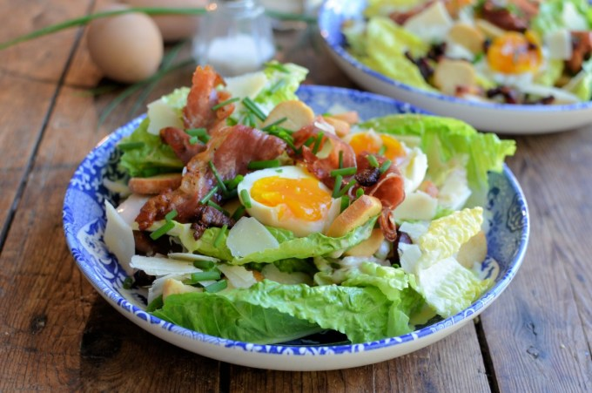
Salad
1-2 little gem lettuce
(leaves separated)
8 rashers of smoked streaky bacon
(grilled until crispy)
4 hard boiled free range eggs
(shelled and quartered)
4 tablespoons croutons
50g shaved parmesan (or more)
a few snipped chives (optional)

Dressing
1 clove garlic (minced finely)
1-2 tins anchovies
25g finely grated parmesan
6 tablespoons dijon mustard
10 tablespoons mayonnaise
(more if you like)
1 tablespoon white wine vinegar
Method

Tear the lettuce into pieces, and arrange in one large serving bowl or four individual bowls.

Make the dressing by mashing the garlic and the anchovies together in a jug or bowl, then add the remaining ingredients and whisk together to make a thick dressing that pours.

Assemble the salad, break up the bacon and place over the top of the lettuce leaves with the quartered eggs and croutons.

Dress the salad with the Caesar dressing and then scatter the cheese shavings over the top with the chopped fresh chives. Serve immediately.

To make your own croutons, take 4 thick slices of bread, and tear them into pieces; place them on a baking tray, drizzle over some olive oil (about 2 to 3 tablespoons), turn the croutons around in the oil so they are all coated and season to taste with sea salt, Bake in pre-heated oven 200C/400F/Gas mark 6 for about 8 to 10 minutes. Once cool, these can be stored in an airtight tin for a week.
This week’s savoury recipe 2

GARLICKY CHESTNUT MUSHROOMS, SPINACH &
POACHED EGGS ON TOAST

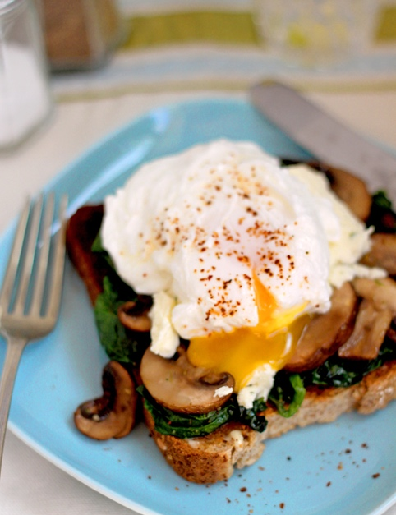
Ingredients – Serves 2

2 cups baby spinach leaves, washed
250g chestnut mushrooms, sliced
1 large clove of garlic, crushed
butter or olive oil for frying
salt and a pinch of cayenne pepper
2 large free-range eggs
2 tsp vinegar
2 generous Tbsp soft creamy cheese
(optional)
2 slices toast (any, sourdough is best)

Method

In a small frying pan, heat a little olive oil or butter and add the garlic. Sauté until sizzling gently, then add the mushrooms for 2-3 minutes and then add the spinach and cook until just wilted. Season to taste with salt and cayenne pepper. Keep warm.

Heat a small saucepan of water until it is almost boiling but not quite. Stir in the vinegar and bring to a gentle boil. Crack the eggs into individual ramekins, then use a spoon to stir the boiling water rapidly so that a little whirlpool forms in the centre. Holding the ramekin close to the surface, slip the egg into the centre of the whirlpool - this will help hold the egg white together. Turn the heat off, cover the pot and allow to cook for 4 minutes (you don't want to overcook the yolk!). Remove the egg from the water with a slotted spoon and keep warm; then repeat the process with the other egg.

Toast and butter the bread. Top each slice with half the spinach-mushroom mix and top this with half the cheese. Place an egg on top of each toast, sprinkle with a little more pepper and serve immediately.

This week’s sweet recipe

BAKED PEACHES WITH RUM, MAPLE SYRUP & CINAMMON
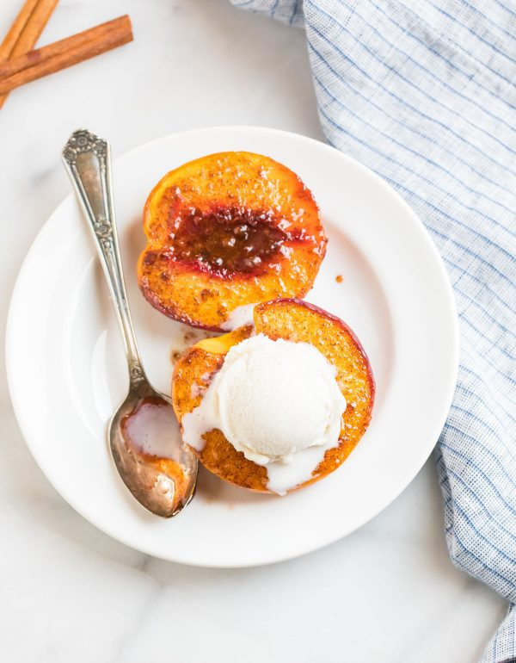
Ingredients, serves 6

3 fresh, ripe peaches,
halved and pitted
2 tablespoons extra virgin olive oil
2 tablespoons pure maple syrup
or honey
1 tablespoon rum
or brandy or bourbon (optional)
1 tablespoon light brown sugar
1 teaspoon pure vanilla extract
1 teaspoon ground cinnamon
¼ teaspoon salt
Vanilla ice cream, Greek yogurt
or double cream, for serving

Method

Preheat oven to 350 degrees F. Lightly coat a 9x9-inch or similarly sized lightly greased baking dish that’s large enough to hold the peach halves in a single layer. Pick a dish that's sized to where your peaches fit comfortably side by side, but there isn't too much excess room around them. Arrange peaches cut-side up in the dish.

In a medium mixing bowl, stir together the oil, maple syrup or honey, run, sugar, vanilla, cinnamon and salt. Spoon the mixture over the peaches, filling the centre and letting it run over the sides.

Bake the peaches uncovered until they are cooked through and fork-tender, about 30 minutes. Serve warm, topped with vanilla ice cream, Greek yogurt, or a pour of heavy cream, as desired.

