D3 Spectrum Business Centre
Anthony’s Way
Rochester ME2 4NP
T: 01634 838775
E: contact@austensgroup.com
W: www.austensgroup.com

VEG BOX CONTENTS & RECIPES FOR WEEK COMMENCING 21st SEPTEMBER 2020
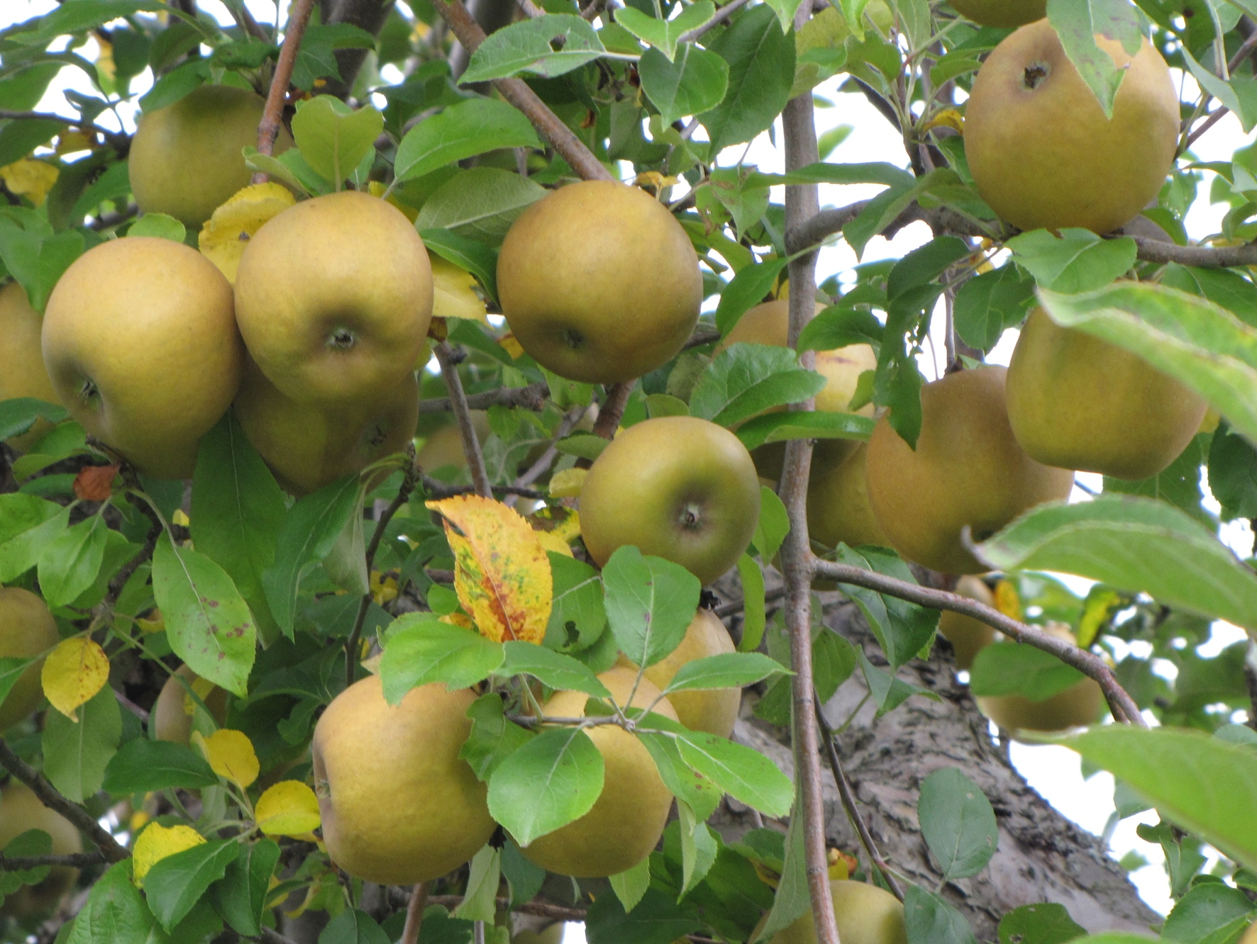

E A T L O C A L ⋅ L I V E B E T T E R

VEG BOX CONTENTS

BOX SIZE &  CONTENTS | SMALL  BOX | MEDIUM  BOX | LARGE  BOX | WHERE IT IS GROWN | STORAGE INSTRUCTIONS
LOCAL RASPBERRIES | √ | √ | √ | Goodnestone | Refrigerate, eat at room temperature
LOCAL RUSSET APPLES | √ | √ | √ | Coxheath | Room temperature
BANANAS | √ | √ | √ | Costa Rica | Room temperature
LOCAL CHIPPING POTATOES | √ | √ | √ | Birchington | Cool, dark place
LOCAL MIXED KALE | √ | √ | √ | Halling | Refrigerate
LOCAL LEEKS | √ | √ | √ | Boughton | Refrigerate
LOCAL BROAD BEANS | √ | √ | √ | Boughton Monchelsea | Refrigerate
RED PEPPERS | √ | √ | √ | Spain | Refrigerate
LOCAL BABY CUCUMBERS | X | √ | √ | Halling | Refrigerate
LOCAL VINE TOMATOES | X | √ | √ | Thanet | Refrigerate
LOCAL ROCKET | X | X | √ | West Malling | Refrigerate
BANANA SHALLOTS | X | X | √ | Spain | Cool, dark place

This week’s savoury recipes

CRUSHED BROAD BEANS ON TOAST

Ingredients – Makes 6
300g broad beans, blanched and
double-podded
1 clove garlic
30g parmesan or similar
plus extra to serve
½ lemon, zested and juiced
75ml extra-virgin rapeseed or olive oil
6 slices sourdough or similar, toasted
1 handful rocket
(optional, medium boxes only)
1 pinch chilli flakes (optional)

Instructions

In a food processor blitz ¼ of the broad beans, all the rocket, garlic, pecorino, lemon zest and juice with the olive oil and some seasoning. Add the remaining broad beans and pulse a few times to leave it chunky.

Spoon onto the toast, sprinkle with chilli flakes and drizzle with olive oil.

THE PERFECT CHIP
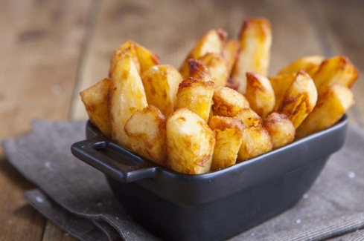
USING THE CHIPPING POTATOES IN YOUR BOX

In this week’s box you’ll find the very best potatoes for chipping. These are used by top chefs because they produce the perfect golden chip. Their skins may not look the best but you won‘t be disappointed with the results – trust us!

Have you been disappointed with soggy, dark brown coloured chips in the past? This is because the amount of water in a potato affects its texture when cooked – too much water will produce soggy chips. Most potatoes have also been stored to maintain their looks but this method of storage turns the starch in the potato to sugar, producing darker, brown coloured chips when cooked.

The chipping potatoes in this week’s boxes are different. To guarantee you the perfect golden chip with the right crunch, chipping potatoes have the ultimate texture and optimum water content, they’re also stored at a higher temperature. Larger sized potatoes are used so you can cut evenly sized longer chips.

Once peeled and cut to the size you like, thin, thick or somewhere in the middle, make sure you wash the chips before cooking but do not soak.
Deep frying is the ultimate way to get a good crispy chip on the outside and a fluffy texture within. Fry at around 185C in sunflower, sunseed or groundnut oil or good old vegetable oil if you have none of these.

Fry once at 140C for around 8 minutes, then remove the chips. If you don’t have a thermometer, use a raw chip and as it starts to float and fry the temperature should be about 140°C. Lower the chips into the pan for around 8 minutes, or until soft but not coloured, then remove to a tray to cool.

Turn the heat up under the oil and return one chip to the oil as a guide again. Once it’s floating and golden the temperature should be about 180°C, which is perfect for frying and will give you chips with those all-important crispy outsides and fluffy middles. At this stage you may want to cook your chips in 2-portion batches, so you don’t decrease the temperature of the oil too much or overcrowd the pan. Fry the chips until beautifully golden, then remove to a bowl lined with kitchen paper, shake around a bit, season with sea salt and serve right away.
This week’s sweet recipe

FRUITY CARAMEL BAKED RUSSET APPLES

Of course some may just want to eat their russet’s straight out of the fruit bowl but if you fancy turning them into a classic dessert instead here’s a delicious indulgent recipe.
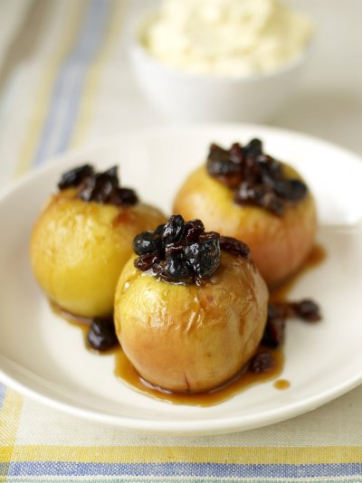
Ingredients – Serves 4

3-4 russet apples
50g butter
50g brown sugar
2 handfuls dried fruit
1 zest of orange
2 tablespoons runny honey
1 tablespoon icing sugar
1 pinch mixed spice
1 splash brandy or whisky (optional)

Instructions

Preheat the oven to 180°C/350°F/gas 4. Carefully remove the core from the apples with a sharp knife or apple corer. Be careful not to split them in half. Place them on a baking tray.

Heat the butter and sugar in a small saucepan with the dried fruit, stem ginger and orange zest. Stir until the butter has melted and all the grains of sugar have disappeared. Pour the caramel mixture into the middle of the apples, drizzling any extra mixture over the top along with the honey. Bake the apples in the preheated oven for 20 minutes.

Meanwhile, whip the double cream with the icing sugar and mixed spice until you have soft peaks. Fold in the brandy or whisky for a bit of a kick if you like.

Serve each apple with a big spoonful of natural yoghurt, crème fraiche or cream and any leftover caramel juices from the tray.

